**SYSTEM DESIGN**: T.C.R.S.

*Overview*

*This System Design Document describes the system requirements, operating environment, system and subsystem architecture, files and database design, input formats, output layouts, human-machine interfaces, detailed design, processing logic, and external interfaces.*

# **INTRODUCTION**

## **Purpose and Scope**

This document reviews & expands on information from accompanying documents and details additional information regarding the design of Traffic Citation and Reporting System.

## System Overview

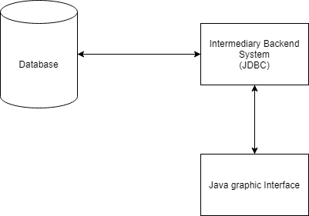

The system utilizes a Java graphic interface to allow users to efficiently send and receive information from a database containing the necessary traffic information (personal information, vehicle details, etc). To achieve this, input from users is sent to a hidden application housed separately for processing; output is also sent to the interface through this backend software.

### Design Constraints

This system does not include functionality concerning traffic cameras or other automated systems. It assumes based on information provided that there is some level of human activity at all stages of the systems input & output.

### **Document Organization**

This section describes the organization of the Systems Design Document.

This document includes information on the planned system architecture, integrity, database design, interfaces, planned human-machine interactions, and other detailed design specifications.

## **Project References**

D2: System Requirements & Specifications

D3: User Interface & Architecture Design

# **SYSTEM ARCHITECTURE**

System and/or subsystem(s) architecture for the project.

## **System Hardware Architecture**

This system uses personal workstations as the medium for user interaction through its GUI, and will house it’s database and internal software on separate servers & machines, connected through the local network. This will lighten the storage and processing load on individual workstations, and centralize the system for ease of installation, updates, etc.

## **System Software Architecture**

The system will utilize an SQL database to store all citation, citizen, & vehicle information, and access, update, and add to that information through use of JDBC hooked into the web interface. The different forms in the interface will correspond to functions built to take their input and place it correctly within the database, or provide output based on the requested information.

## **Internal Communications Architecture**

The devices used to house and operate the system will communicate via the local government’s network service. The security of information will be primarily protected through the use of a login service for authentication of users.

# **FILE AND DATABASE DESIGN**

## **Database Management System Files**

The database will utilize SQL for its construction and management. It will include separate tables for persons, vehicles, warrants, and citations. These tables will be linked by keys that ensure accurate grouping of vehicles, warrants, & citations with the citizens they are related to (owners, offenders).

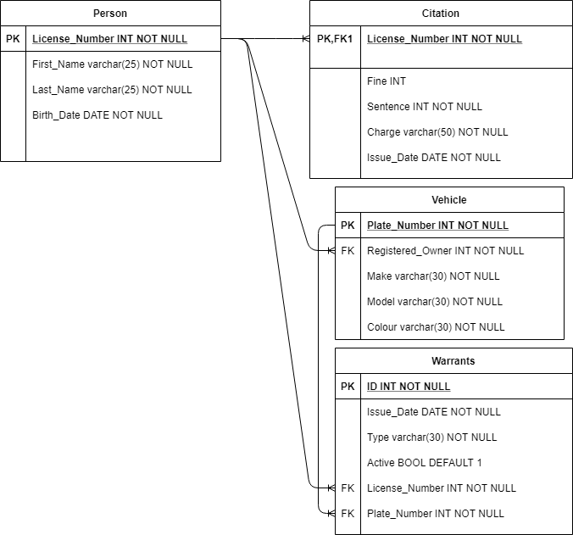

## **Non-Database Management System Files**

The non-database portion of the system consists of the webpage files that will contain the user interface and the Java-based backend software that will manage communication between the interface and the database through use of JDBC. The interface will not be split into a high volume of different pages; instead much of the search functionality will be contained to screens that are managed by tabs. The interface includes, in total: a landing (home) page, report generation screen, pages for warrants, person searching, & vehicle searching. Most of these pages will include one or more forms for intake of new information and output of requested information. Examples of the planned layout of these screens can be viewed in the User Interface design document, as well as section 4 of this document.

# **HUMAN-MACHINE INTERFACE**

This section provides the detailed design of the system and subsystem inputs and outputs relative to the user/operator.

## 4.1 **Inputs and outputs**

* about the privacy and security

Every user will have his/her own ID and Password. when they logged in to their account they will have to verify their identity by providing their question answer that they have set.

after that it will take them to the home screen .

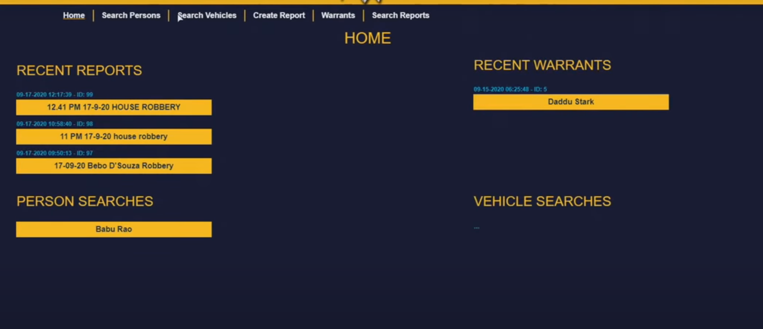

As you guys can see this is our home screen for this project and from this screen you can create any kind of report about the suspect and crime that he did.

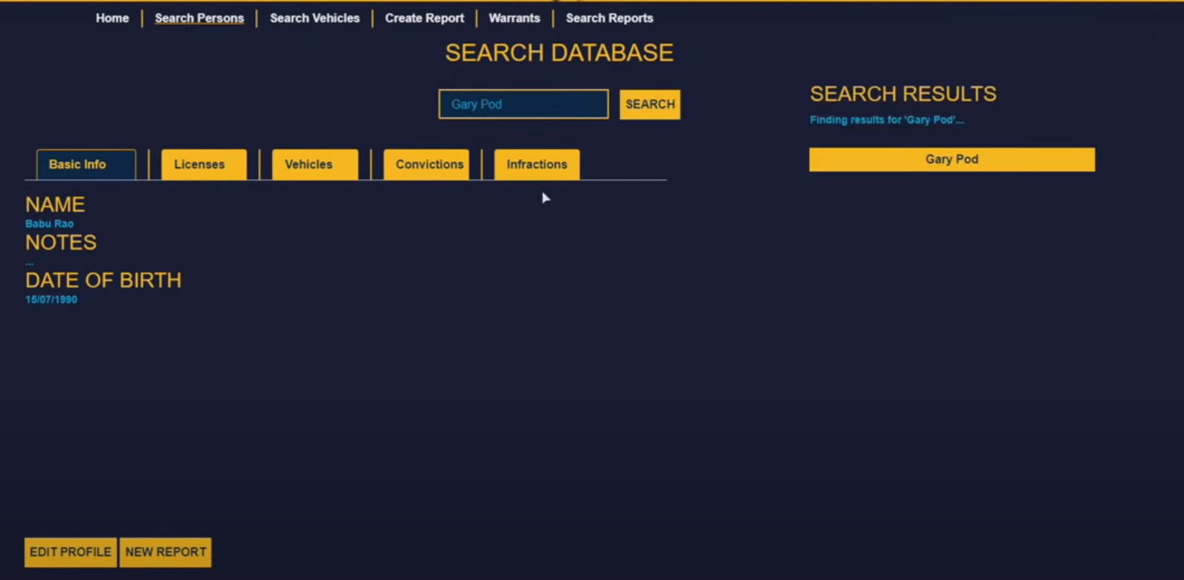

beside the home screen you will find the “Search Persons” by clicking on that you will be able to see his/her history.

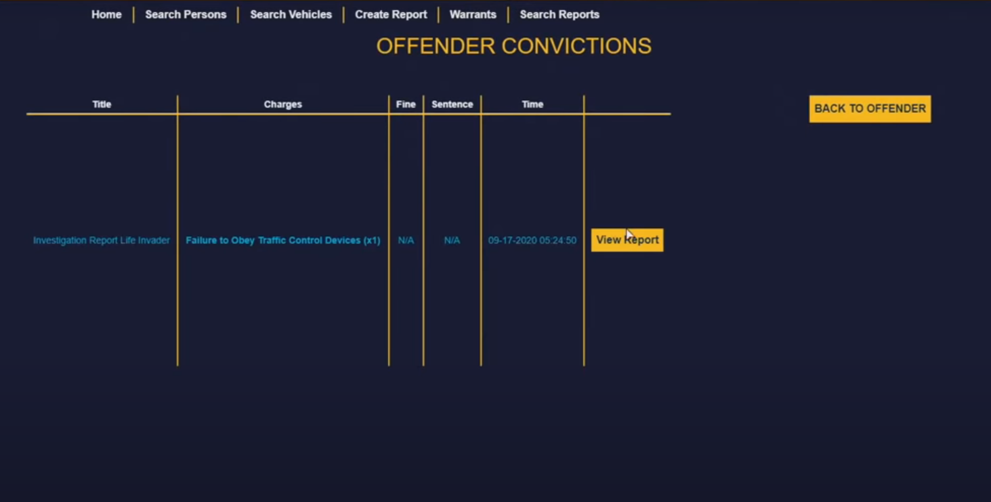

after searching the suspect name you will be able to find his/her most recent report ex. like this one we have provided above “Failure to obey Traffic control Device”. after that you can view their report by clicking “View Report”.

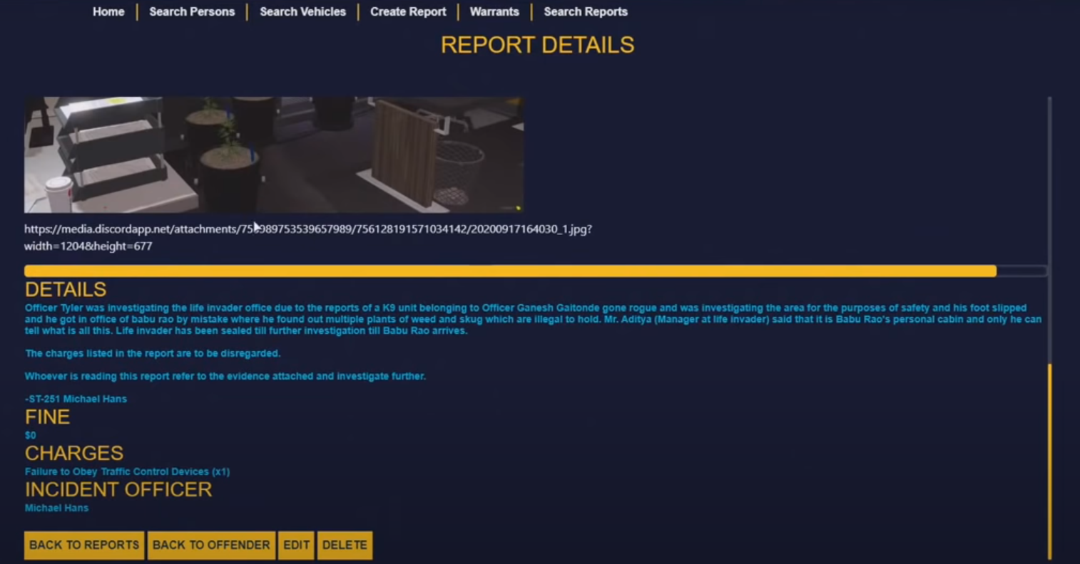

After clicking on the view report you will be able to see his/her previous report, fine, charge and details about the incident and you can make a change to by clicking on the “edit” button.

# **DETAILED DESIGN**

This section provides the information needed for a system development team to actually build and integrate the hardware components, code and integrate the software modules, and interconnect the hardware and software segments into a functional product. Additionally, this section addresses the detailed procedures for combining separate COTS packages into a single system. Every detailed requirement should map back to the FRD, and the mapping should be presented in an update to the RTM and include the RTM as an appendix to this design document.

## **Hardware and software Detailed Design**

Our application will run in window and this application won’t be for normal public this

system will only be installed in government workers (police officers) systems. and for

security purposes you will have to verify your identity.

* Power input requirements for each component
* Signal impedances and logic states
* Connector specifications (serial/parallel, 11-pin, male/female, etc.)
* minimum RAM requirements is 2GB
* minimum storage requirements is 4GB
* Dual-core 2GHz or higher(intel i3, i5, i7 or AMD equivalent)
* Cable type(s) and length(s)
* User interfaces (buttons, toggle switches, etc.)
* maximum 250GB Storage
* does not matter, it works with any Monitor resolution
* Report layout

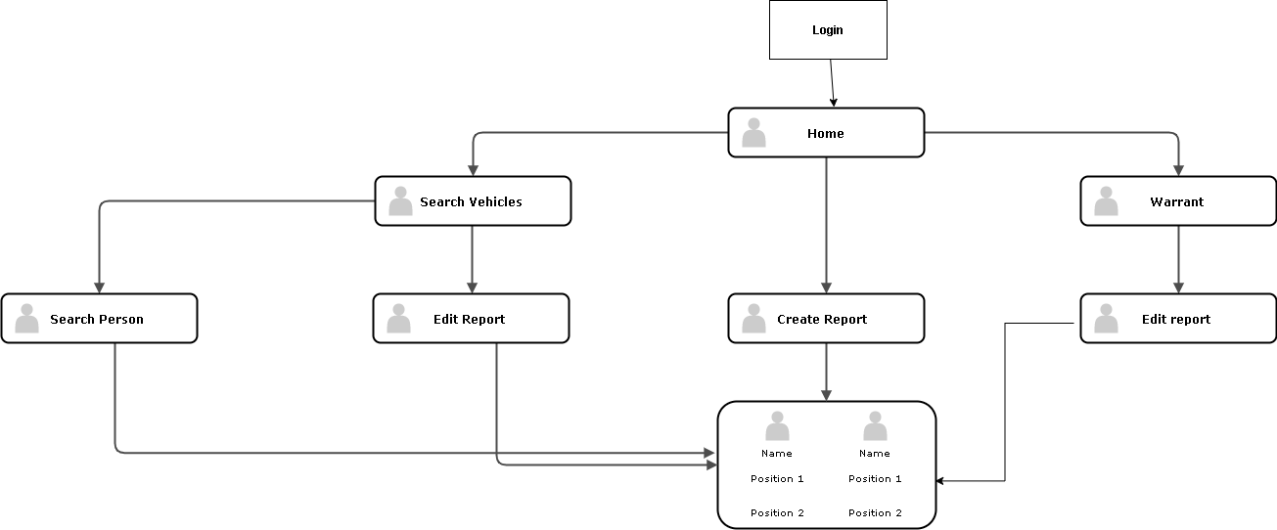

## **Internal Communications Detailed Design**

* For each state there will be a different database so users don’t get confused.
* After login this system will take you to the online database drive and the report created will be saved in the system so others can see the report.
* the data will be saved in the online database system so everyone can easily see other data and share other information.
* LAN topology

# **EXTERNAL INTERFACES**

## **Interface Architecture**

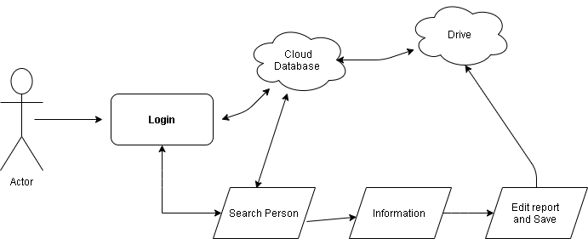

This is how the report system works. You can get the Information form the database and you can upload information to the database. it will be easy for them to keep track of the report without worrying about, they don't have to worry about uploading manually it will automatically by itself.

## **Interface Detailed Design**

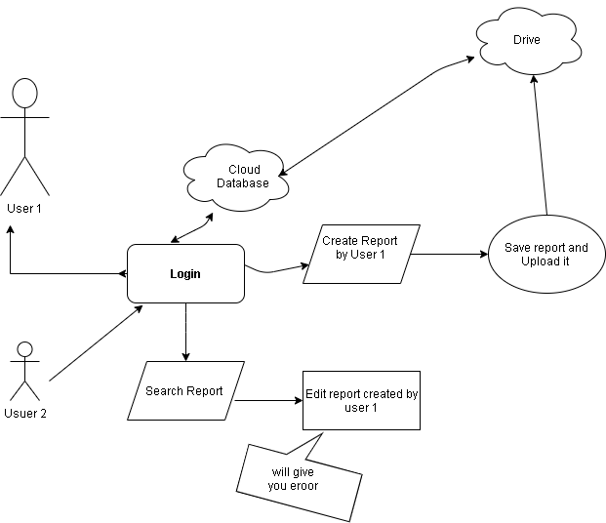

This will give you an error because you can not edit a report that has not been created by you system will give you error if you try to edit the old report created by some other user it will give you error for the safety reason.

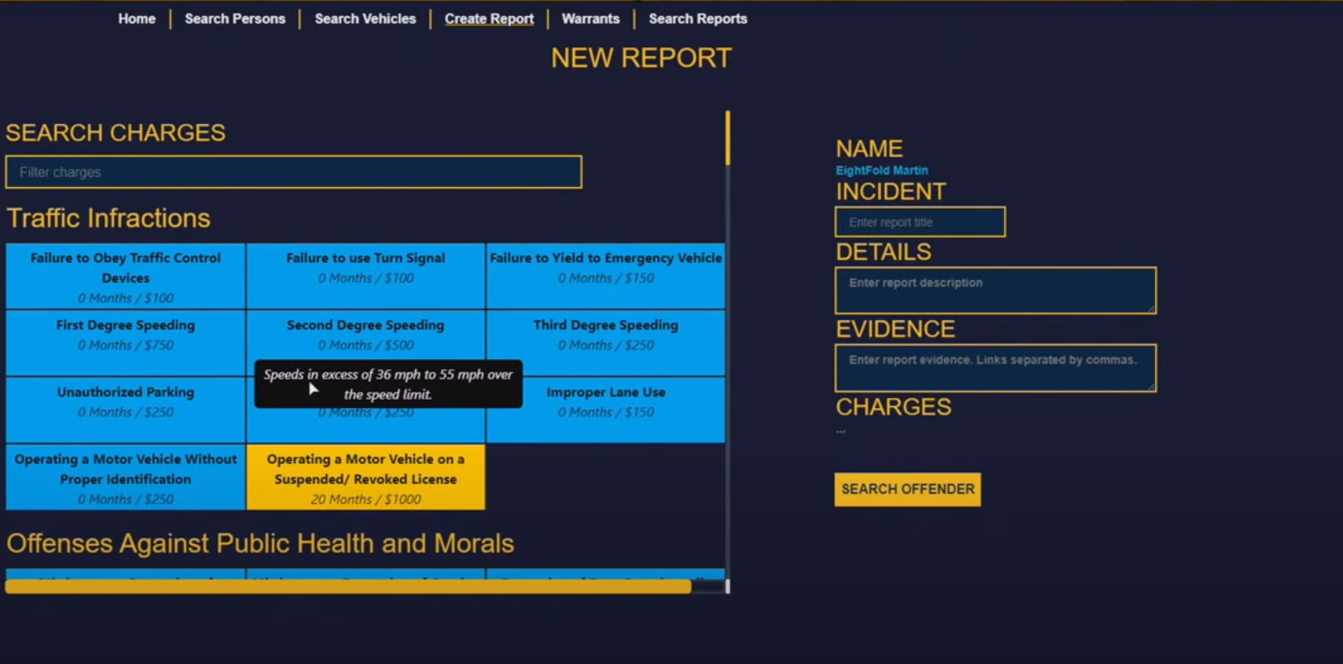

This is how the new report screen looks like, you just have to click on the charges. It will automatically give you a fine and the sentence if needed.

# **SYSTEM INTEGRITY CONTROLS**

The system will have it’s access controlled through a login system that requires the user to have a valid account created by a high-level authorized individual. Inputs will be sanitized before submission to the database to avoid unintentional, erroneous, or malicious input. Report generation functionality will allow for ease of executive or external review.